Beta Chi Chapter of The Delta Kappa Gamma Society International Inducts New Members

The Beta Chi Chapter of the Delta Kappa Gamma Society International held its November meeting on the 10th at 5:00 p.m. at Harrisonburg First Baptist Church. A special induction ceremony was led by chapter members. Beta Chi Chapter was pleased to welcome two new members, Lorette Poole and Megan Grant. Ms. Poole teaches 11th &12th grade at Block High School, and Mrs. Grant teaches special education at Harrisonburg High School.
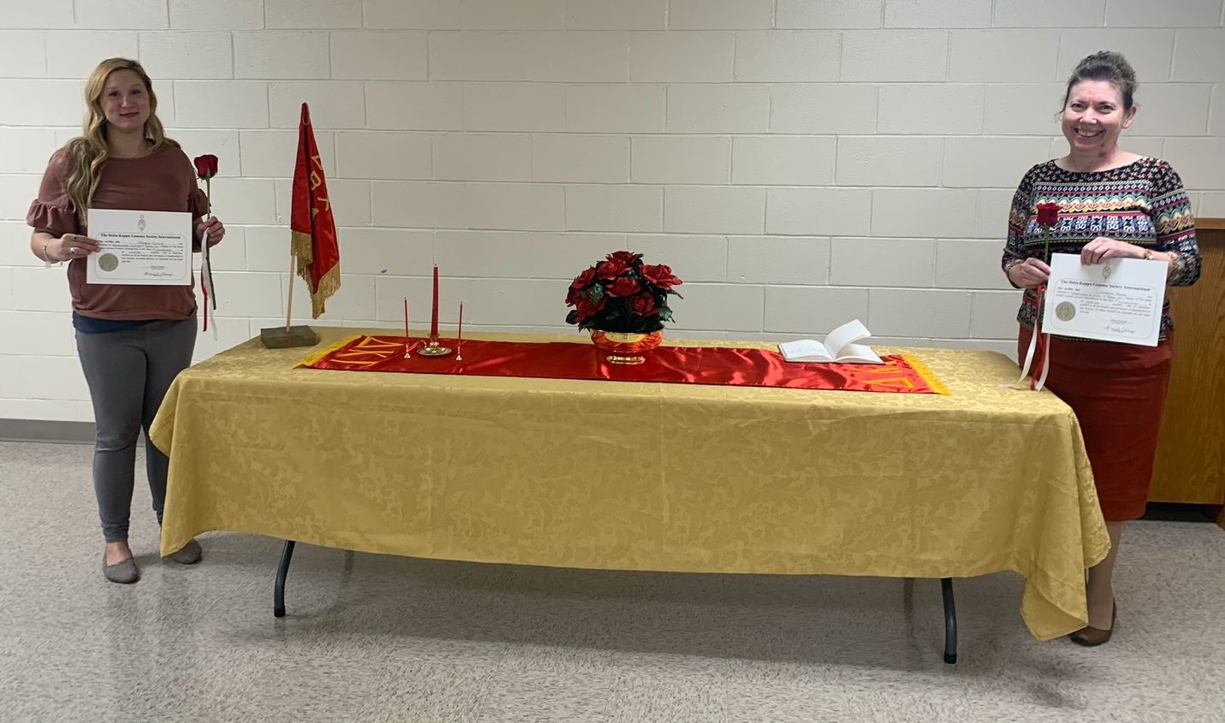
Mega Grant (left) and Lorette Poole (right) have pledged their loyalty to The Delta Kappa Gamma (ΔΚΓ) Society, which was founded in 1929 as a medium through which women leaders in education might gain recognition. The seven purposes of the society are:
- To unite women educators of the world in a genuine spiritual fellowship.
- To honor women who have given or who evidence a potential for distinctive service in any field of education.
- To advance the professional interest and position of women in education.
- To initiate, endorse, and support desirable legislation of other suitable endeavors in the interests of education and of women educators.
- To endow scholarships to aid outstanding women educators in pursuing graduate study and to grant fellowships to non-member women educators.
- To stimulate the personal and professional growth of members and to encourage their participation in appropriate programs of action.
- To inform the members of current economic, social, political, and educational issues so that they may participate effectively in a world society.
Beta Chi Chapter would like to thank the Harrisonburg First Baptist Church for the use of its facilities. Visit our website at https://deltakappagammaepsilonbetachi.weebly.com/ to learn more about the Beta Chi Chapter of The Delta Kappa Gamma Society International.
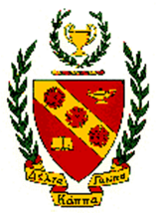
Article & Photo by Dr. Tia Neal

