Beta Chi Chapter of The Delta Kappa Gamma Society International Holds November Meeting
The Beta Chi Chapter of the Delta Kappa Gamma (DKG) Society International held its November meeting on the 9th at 5:00 p.m. at the home of Dr. Tia Neal. A recommitment ceremony was facilitated by President Mary Jo Williams in which members focused on the implementation of the seven purposes. President Williams also dedicated part of the meeting to remembering our founders. Dr. Tia Neal gave the devotional entitled “Bee Sisters”, reminding everyone that just as honey bees work together for a common goal, DKG sisters are called to do the same. As educators and members who adhere to the first purpose of our society, we must “unite women educators of the world in a genuine spiritual fellowship” and work together for a common goal in order to thrive in the ever changing world of education.
After a delicious meal catered by Mrs. Carmen LaCroix, members were treated to a special presentation by Mr. David Neal of Tew Lake Nursery, who spoke on the benefits of having plants in your home as well as how to take care of fall foliage. Mr. Neal, who retired after 30+ years of working for the Louisiana State University AgCenter as the county agent, shared research from the National Aeronautics and Space Administration (NASA). According to NASA’s research, having houseplants can reduce your stress and anxiety, purify the air in your living space, as well as aid in reducing depression.
Mr. Neal (right) is pictured here with DKG’s state executive secretary, Dr. Lori Myers of Theta Chapter, who visited Beta Chi’s meeting for the evening (left).
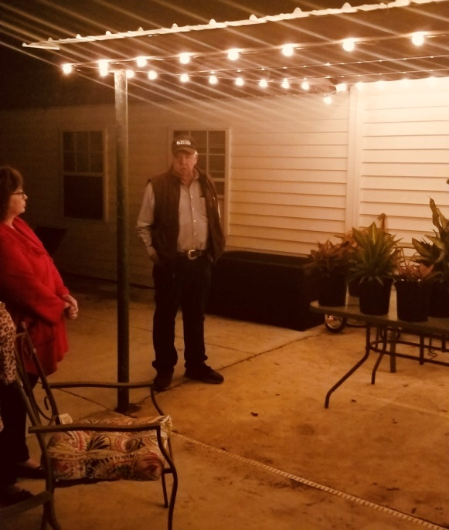
The seven purposes of The Delta Kappa Gamma Society International are as follows:
- To unite women educators of the world in a genuine spiritual fellowship.
- To honor women who have given or who evidence a potential for distinctive service in any field of education.
- To advance the professional interest and position of women in education.
- To initiate, endorse, and support desirable legislation of other suitable endeavors in the interests of education and of women educators.
- To endow scholarships to aid outstanding women educators in pursuing graduate study and to grant fellowships to non-member women educators.
- To stimulate the personal and professional growth of members and to encourage their participation in appropriate programs of action.
- To inform the members of current economic, social, political, and educational issues so that they may participate effectively in a world society.
A special thanks to Kathy LeMay at Boggy Bayou Designs for designing a custom door prize for the chapter meeting.
To learn more about the Delta Kappa Gamma Society International, please visit our website at https://deltakappagammaepsilonbetachi.weebly.com/ .
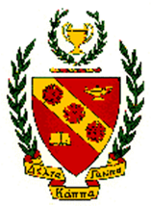
Photo: Mr. Cole Neal
Article: Dr. Tia Neal

