Beta Chi Chapter of Delta Kappa Gamma Inducts New Member
The Beta Chi Chapter of the Delta Kappa Gamma Society International held its October meeting on the 12th at 5:00 p.m. at Utility Baptist Church. A special induction ceremony was led by chapter members. Beta Chi Chapter was pleased to welcome a new member, Jordon Hudspeth. Ms. Hudspeth teaches special Education at Harrisonburg High School. Ms. Hudspeth (right) is pictured here with member, Dr. Tia Neal (left), after receiving her certificate and pledging her loyalty to The Delta Kappa Gamma Society International, which was founded in 1929 as a medium through which women leaders in education might gain recognition.
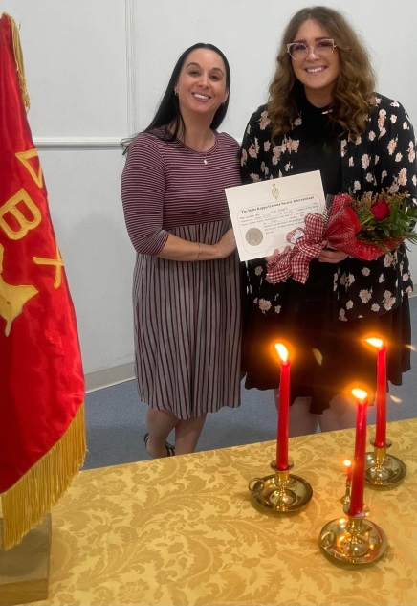
The seven purposes of The Delta Kappa Gamma Society International are as follows:
- To unite women educators of the world in a genuine spiritual fellowship.
- To honor women who have given or who evidence a potential for distinctive service in any field of education.
- To advance the professional interest and position of women in education.
- To initiate, endorse, and support desirable legislation of other suitable endeavors in the interests of education and of women educators.
- To endow scholarships to aid outstanding women educators in pursuing graduate study and to grant fellowships to non-member women educators.
- To stimulate the personal and professional growth of members and to encourage their participation in appropriate programs of action.
- To inform the members of current economic, social, political, and educational issues so that they may participate effectively in a world society.
The Delta Kappa Gamma Society International promotes professional and personal growth of women educators and excellence in education, and Beta Chi Chapter is honored to have Ms. Hudspeth join us as a new member!

